**Science Worksheet**

**Grade III**

# 

**NAME: ___________________**

# QI: Label the human skeletal system.

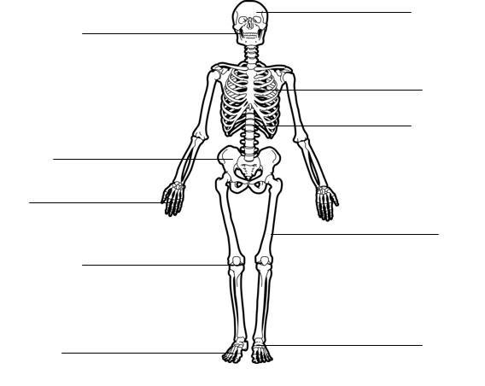

| Skull | Spine | Toe bone | Hip bone | Fingers |
| --- | --- | --- | --- | --- |
| Heel | Jaw bone | Ribs | Kneecap | Thigh bone |

# Q2 : Match column A with column B.

1. Heart *carry the oxygenated blood from the heart to all parts of the body.
2. Arteries *return the blood to the heart from all parts of the body.
3. Veins *is the strong muscle, which pumps blood around  the body.

**Q3: Label the human brain and color it.**



# Q4: Fill in the blanks.

| eating | machines | electricity | animals |
| --- | --- | --- | --- |
| drinking | sight | hearing | water |

1. We should wash our hands before ____________________ and ___________________.
2. We should be careful when using _____________________ and ___________________.
3. Loud noises can damage our _________________________.
4. Bright lights can damage our _______________________.
5. We should be aware of the dangers when we are near _____________________ or ___________________.

# Q5: Match each body part to the correct system.

1. Muscles *Nervous System.
2. Bones * Digestive System.
3. Arteries *Skeletal System.
4. Nerves *Muscular System.
5. Stomach *Circulatory system.